**Creating Net Banking Action**

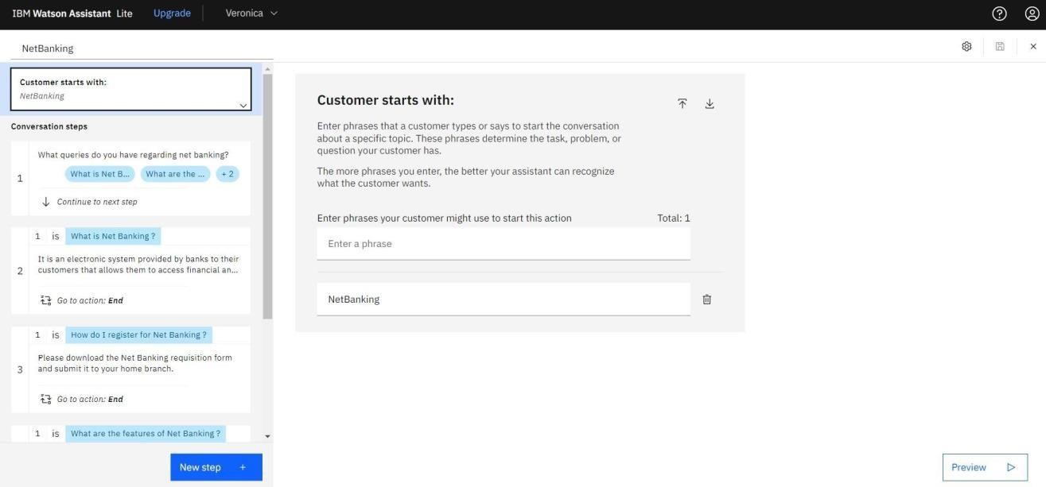

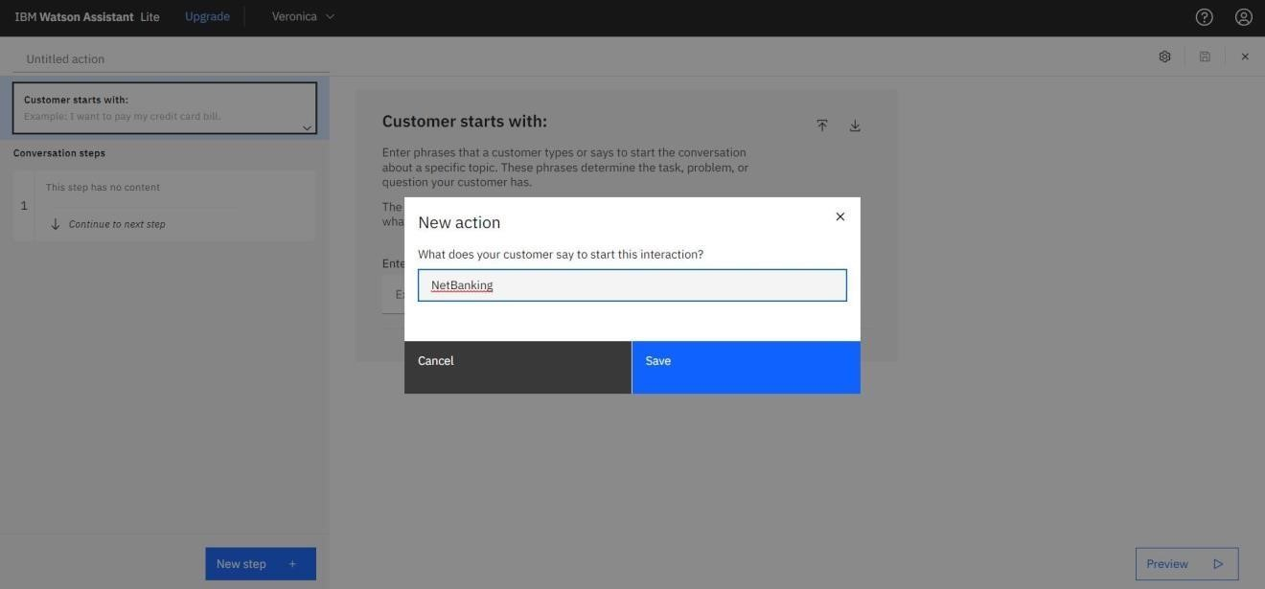

Adding steps in Net Banking Action skill to handle queries of customers regarding significance and issues of net banking.

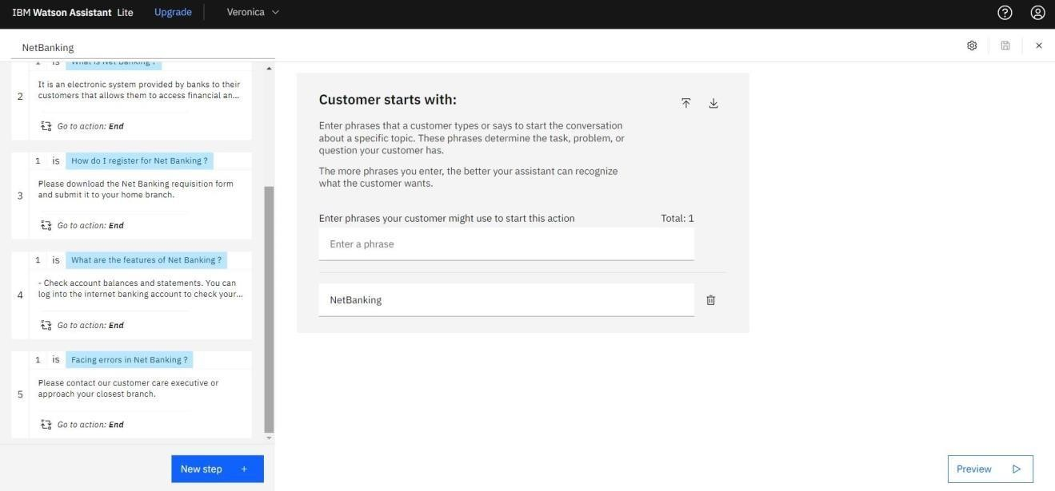

In addition to this greeting, end greeting ,index and end actions are also created.

